Project Design Phase
Solution Architecture
Date | 03 October 2026
Developer / Student | Vinay Krishna A K
Project Name | Automated Network Request Management in ServiceNow

- Technical Solution Architecture Diagram
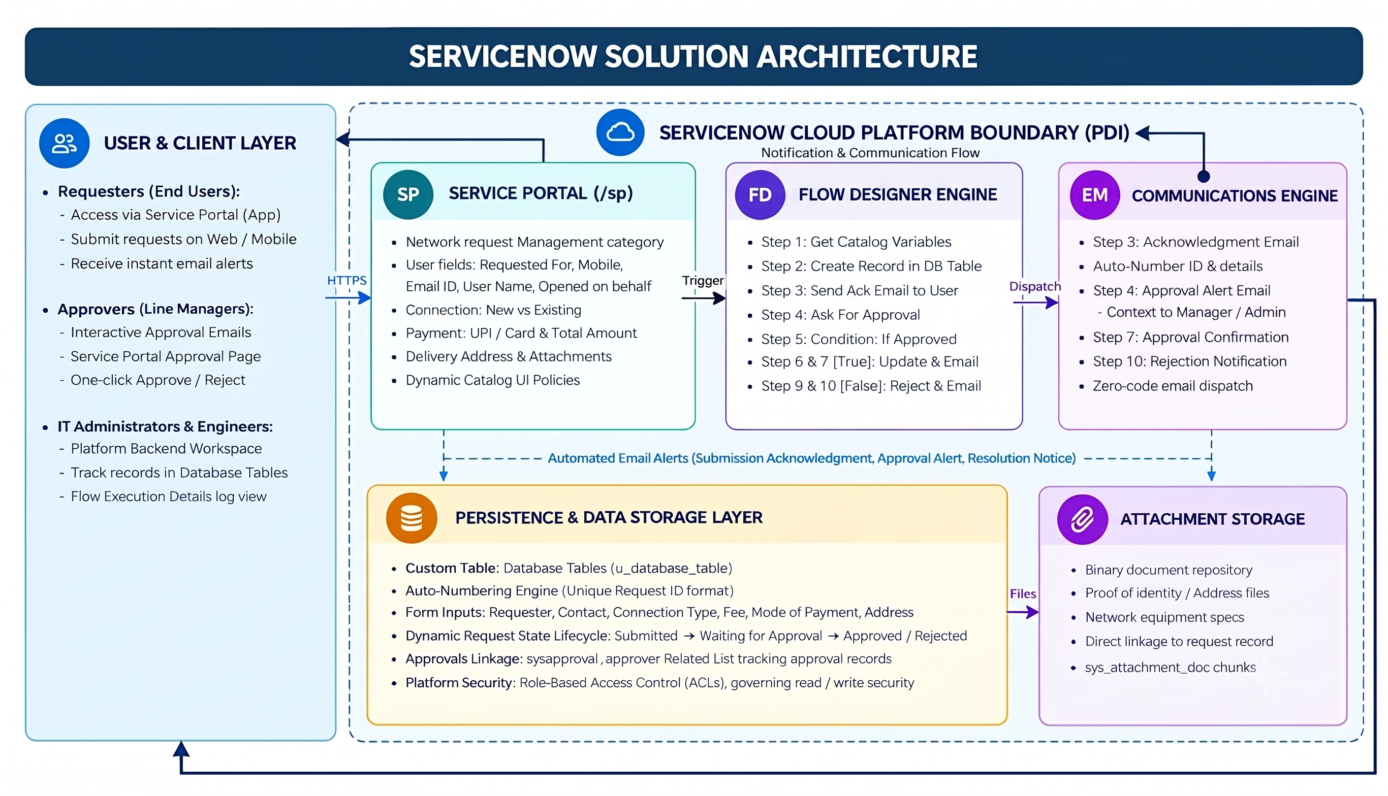

Architecture Overview: The solution architecture defines the multi-tiered structure implemented in the ServiceNow Personal Developer Instance (PDI). It connects the user experience on the Service Portal (/sp) with backend relational data models and zero-code workflow automation. Requests flow from client-side intake forms, through Flow Designer logic for automated validation and manager approval, into the custom Database Tables (u_database_table) schema, with milestone notifications dispatched back to requesters via platform email services.

- Architectural Tiers & Component Specifications

Layer / Tier | ServiceNow Component | Role & Implementation Details
Presentation / Client Tier | Service Portal (/sp) & Service Catalog | • Hosts 'Network Request' catalog item under 'Network request Management'.  • Dynamic Catalog UI Policies show/hide fields conditionally.  • Captures: Requested For, Opened on behalf of, User Name, Phone, Email, Mobile, Type of Connection (New/Existing), Total Amount, Mode of Payment (UPI/Card), Address, and Attachments.
Business Logic Tier | Flow Designer (10 Steps) | • Trigger: Service Catalog on form submission.  • Step 1: Get Catalog Variables from Network Request.  • Step 2: Create Record in Database Tables (u_database_table).  • Step 3: Send instant Acknowledgment Email to Requester.  • Step 4: Ask For Approval on Database Tables.  • Step 5: Evaluates approval condition (true = Approved, false = Rejected).  • True Branch (Steps 6-7): Update Record (Approved) + Send Approval Email.  • False Branch (Steps 9-10): Update Record (Rejected) + Send Rejection Email.
Persistence Tier | Custom Table: Database Tables (u_database_table) | • Custom relational table with unique Auto-Numbering for tickets.  • Stores all submitted variables, payment details, and address.  • Maintains real-time Request State (Submitted, Waiting Approval, Approved, Rejected).  • Integrates with sysapproval_approver for approval audit tracking.
Communications Tier | ServiceNow Outbound Email Engine | • Integrates with platform SMTP service to dispatch automated notifications.  • Generates dynamic milestone emails containing ticket Auto-Number, user details, and approval decisions at Steps 3, 7, and 10.
Security & Governance Tier | Platform Access Control Lists (ACLs) | • Role-Based Access Control (RBAC) enforced via platform ACLs.  • Requesters have read access to their own submissions.  • Approvers and administrators have governed update/approval permissions.  • Full execution logs available in Flow Execution Details for audit compliance.

- Solution Design Principles & Quality Attributes

- Zero-Code Maintainability: The entire workflow is built using native Flow Designer actions without writing custom Script Includes or Business Rules, reducing technical debt and enabling visual debugging.
- Data Integrity & Validation: Catalog UI Policies prevent blank submissions by validating mandatory fields (Connection Type, Phone, Email, Payment Mode) before records are created in Database Tables.
- End-to-End Traceability: Every request generates a unique Auto-Numbered record linked with approval history in sysapproval_approver and logged email dispatches for complete audit readiness.
- Extensible Foundation: The architecture easily accommodates future enterprise enhancements, such as connecting to network configuration tools (Cisco DNA Center, Ansible) via Integration Hub spokes.

